Caterpillar Foundation Matching Gifts Program Process – St. Jude Runs

- Visit www.caterpillar.com/matching-gifts and click on “Visit Website” under “Caterpillar Participants: Search/Request a Match”

- Register as a first-time user OR login as an existing user. Use your 7-digit HR ID (formerly known as PeopleSoft/HR ID - found in CLUES). Make sure that you include the leading “0” at the beginning of your ID (0_ _ _ _ _ _) so that it is 7 digits total. If you do not know your ID, email Matching_Gifts@cat.com.
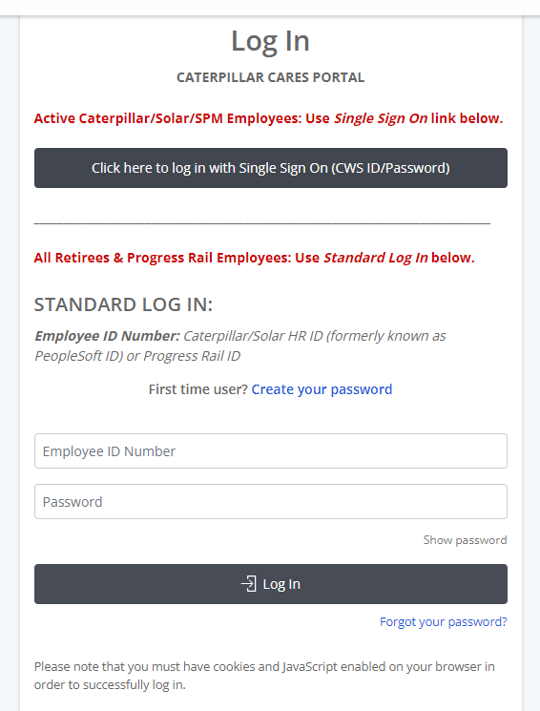

- Click “I ACCEPT” to the matching gifts terms and conditions.
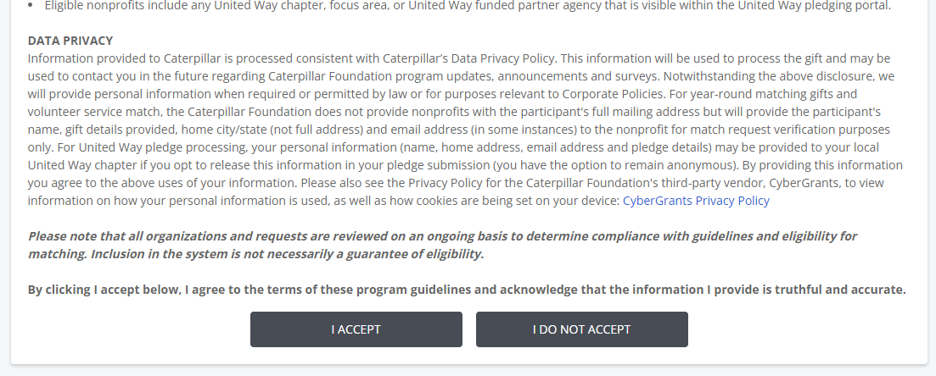

- From the home page, click “1:1 Matching Gifts”.

- In the Matching Gifts Nonprofit Search, type in “St Jude Runs” and click “Search”.
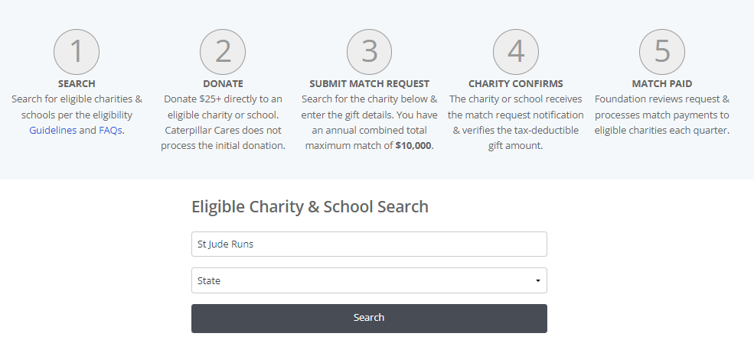
- Click on “Select” next to “St Jude Runs – St Jude Runners Association”.
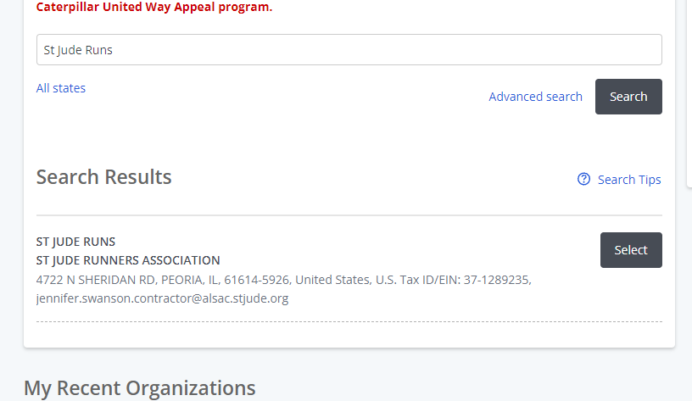

- Enter gift details. If you would like a specific Runner to get credit for this matching gift, type the Runner’s Name and the Satellite City of the Run they participate (if known), in the “Designation” field. Click “Save and Proceed”.
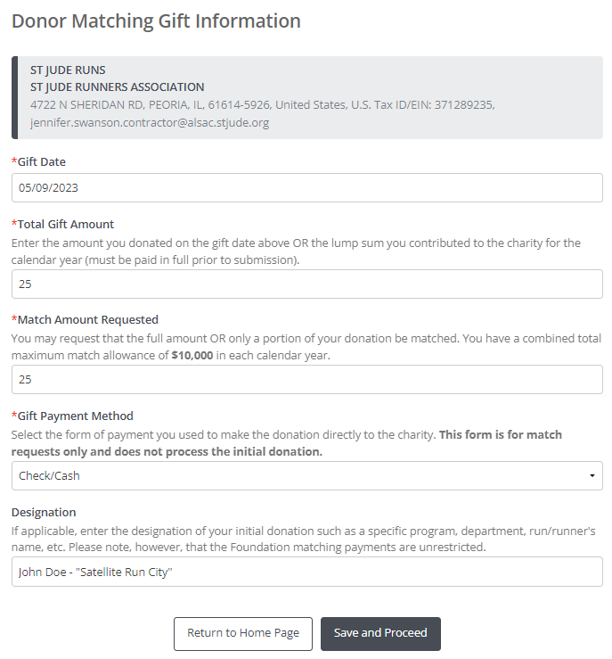
- Review, update (if necessary), and then click “Submit”.
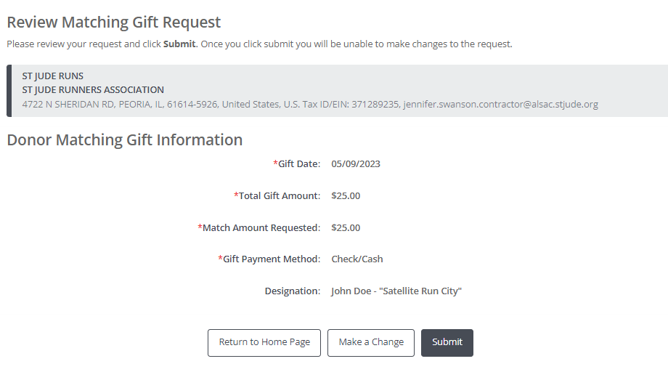

- Click “Email Match Request to Charity” or “Print and Mail Request to Charity”.
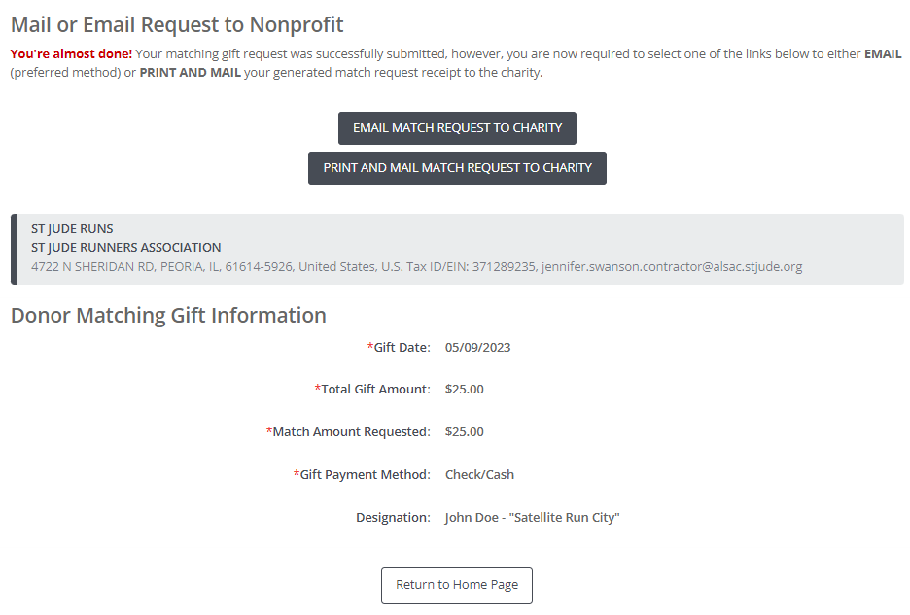

- To email, enter jennifer.swanson.contractor@alsac.stjude.org into the recipient field. Scroll down and click “Preview”. (You do not need to upload any attachments or include additional messages.)
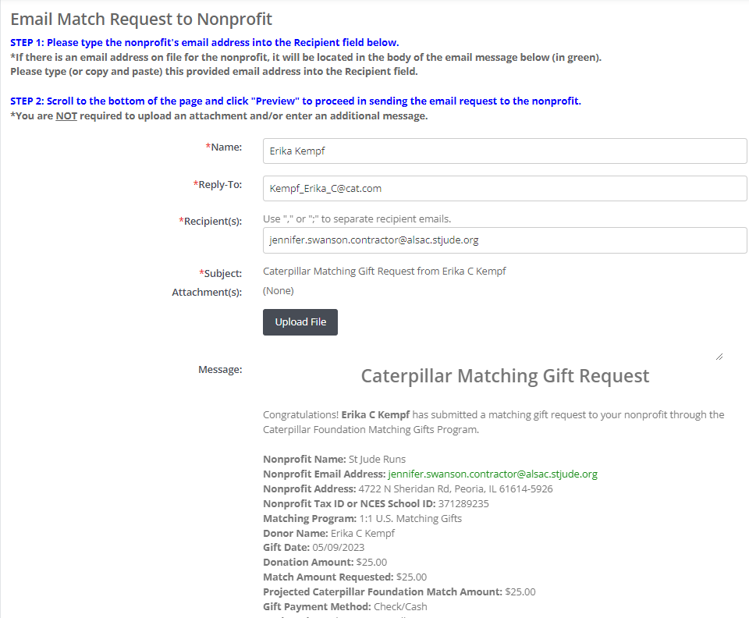

- Scroll down and click “Send”. The process is then complete!
